- Log in to your JIRA test project and create a new test case for the 'Add to Cart' feature found in shopping apps like Flipkart or Myntra, including a clear summary and description.
Ans=>
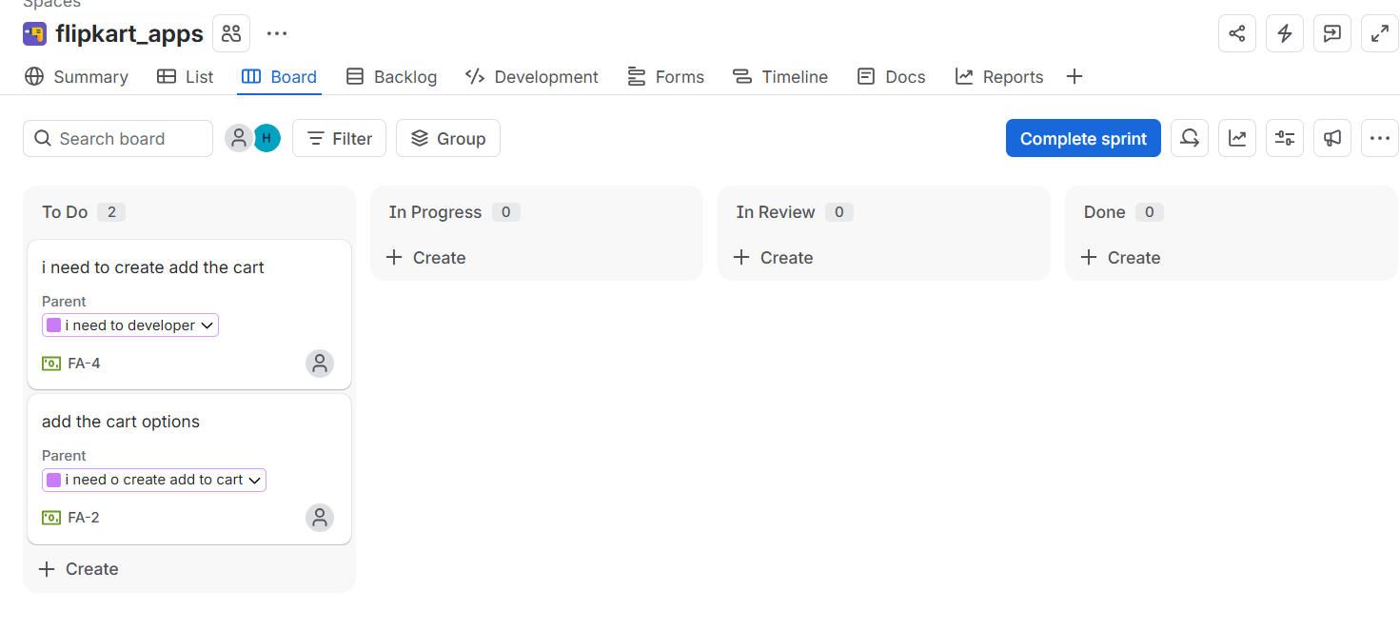

- Link your newly created 'Add to Cart' test case to an existing user story or epic in JIRA that represents the shopping cart module.<br><br><em><strong>Hint:</strong> Use the 'Link Issue' or 'Associate to Story' option in the test case details.</em>
Ans=>
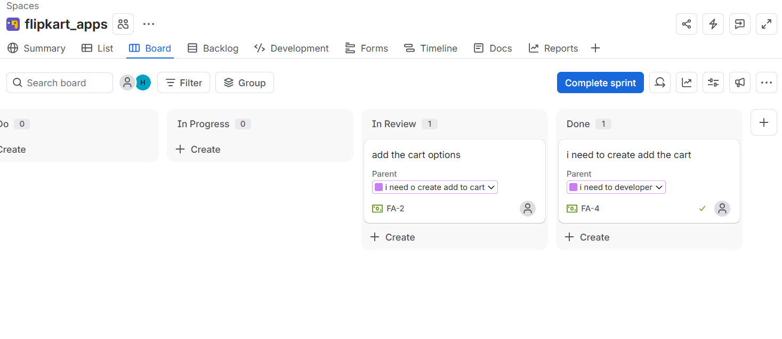

- Add at least two relevant attachments (such as a screenshot of the cart UI and a sample test data file) to your 'Add to Cart' test case in JIRA.
Ans=>
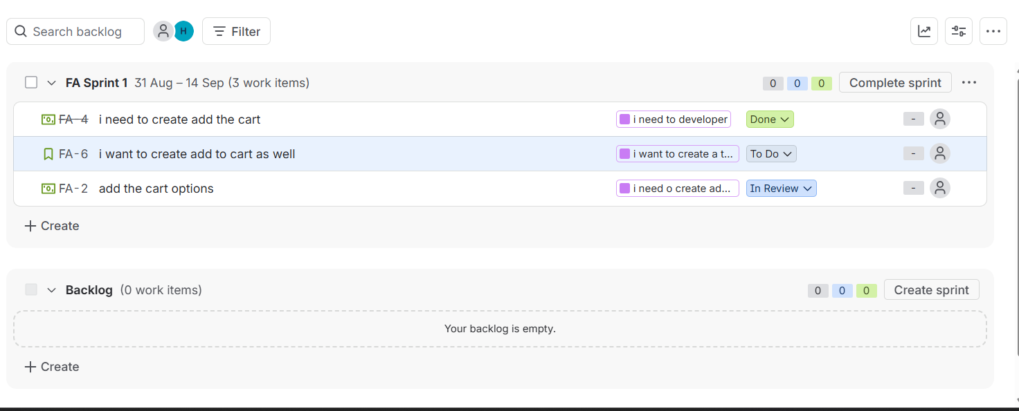

- Write three acceptance criteria for the 'Add to Cart' test case in JIRA, making sure they are clear, measurable, and relevant to typical e-commerce app behavior.
Ans=>

- Product is added successfully: Given an in-stock product, when the user clicks “Add to Cart,” the product is added to the cart within 2 seconds, and the cart item count increases by 1.
- Correct product details are retained: The cart displays the same product, selected size/color (if applicable), quantity, and unit price chosen by the user on the product page.
- Cart total updates correctly: When a product is added, the cart’s subtotal equals the product price × quantity, including any applicable discounts or promotions shown to the user.

- Choose a signup or login test case you entered in JIRA and revise it to add more technical depth: include detailed preconditions, test data, and expected results for both valid and invalid input scenarios.<br><br><em><strong>Hint:</strong> Think about edge cases like blank fields, special characters, or already registered emails.</em>
Ans=>
Preconditions =
- Signup page is accessible over HTTPS.
- User is not already authenticated.
- Signup API/service is available.
- Test email addresses are available.
Test Data
- Valid name: Rahul Sharma
- Valid email: rahul.test+01@example.com
- Valid password: Test@12345
Scenario | Input | Expected Result
Valid signup | Valid name, unique email, compliant password | Account is created successfully; user receives the configured confirmation/verification prompt and is not shown a validation error.
Blank fields | One or more required fields empty | Signup is rejected; each missing required field displays a clear validation message; no account is created.
Invalid email | rahul@ | Signup is rejected with an email-format validation error; no API/account creation occurs.

